CET351 Research Paper
Assignment Cover sheet

Student name: Mandip Sapkota
Student Registration Number: 239759610
Students Degree: Computer Systems Engineering
Off Campus Centre or College: International School of Management and Technology
Research Paper title: “Optimizing AI-Driven Computing for Scalable Deep Learning in Medical Diagnostics and NLP Applications”
Word count: 2822
Relevance of this research topic: In today's technological environment, optimizing AI-driven computing for scalable deep learning is extremely important, especially in the fields of natural language processing (NLP) and medical diagnostics. AI models must effectively scale to manage enormous datasets due to the growing requirement for real-time, large-scale data processing, particularly in industries like healthcare. Optimized AI systems that can handle complicated patient data are beneficial to medical diagnostics because they can produce more precise diagnoses and individualized treatment recommendations. In a similar vein, scalable models are necessary for NLP applications like chatbots, language translation, and sentiment analysis to comprehend enormous volumes of unstructured text input. In order to meet the urgent need for scalable and effective deep learning models in these high-impact fields, this study investigates optimization techniques to improve the performance of AI systems.

Optimizing AI- Driven Computing for Scalable Deep Learning in Medical Diagnostics and NLP Applications

Mandip Sapkota

Abstract
Artificial Intelligence (AI)-driven deep learning models must be optimized to provide scalability and efficiency due to the growing complexity and volume of data in domains such as medical diagnostics and Natural Language Processing (NLP). This study examines optimization strategies used to improve AI computing for scalable solutions, specifically in NLP and medical diagnostics applications. It looks at modern methods, such as cloud computing, distributed and parallel computing, and data optimization strategies, and assesses how well they work to get beyond scaling issues. The study finds gaps in current procedures by critically analyzing the literature, pulling on different papers on the subject. Key findings indicate that the scalability and performance of AI can be greatly enhanced by hybrid optimization tactics that combine distributed computing and cloud infrastructure with sophisticated algorithmic techniques and model compression methods. This research aims to contribute to the development of efficient AI models capable of processing large-scale datasets in real-time applications while addressing computational challenges. Future research directions focus on developing more efficient algorithms and enhancing data processing techniques to further improve model scalability and accuracy.

- Introduction
Deep learning (DL) models are at the vanguard of the revolution in a number of fields brought about by artificial intelligence (AI)-driven computers. AI has particularly demonstrated great promise in the fields of natural language processing (NLP) and medical diagnostics, two fields that depend more and more on the capacity to handle and analyze vast volumes of complicated data in real time. However, the difficulty of effectively optimizing deep learning models becomes critical as the volume of data increases. This study addresses the computational difficulties presented by big datasets in medical imaging and natural language processing applications by enhancing AI-driven computing for scalable deep learning in various fields. Artificial intelligence (AI) models, in particular convolutional neural networks (CNNs), have shown remarkable effectiveness in medical diagnostics by analyzing medical pictures, identifying anomalies, and supporting decision-making. However, conventional deep learning models frequently find it difficult to scale effectively due to the exponential growth of medical data, which causes problems with computational resources and model training time. A number of strategies have been put out to deal with these problems, such as hardware acceleration, parallel processing, and model compression, all of which can enhance scalability and lower latency (Zhou et al., 2020).
Similarly, scalable deep learning models are required to process large amounts of text input in NLP applications such as machine translation, sentiment analysis, and question-and-answer systems. Language models like GPT-3 and BERT have pushed the limits of NLP performance, but they also have scaling issues. These models have been optimized using techniques such as transfer learning, distributed computing, and model pruning (Devlin et al., 2018; Vaswani et al., 2017) these advancements seek to achieve a balance between retaining model performance and lowering computing cost, enabling NLP systems to handle larger datasets and more demanding jobs.
The relevance of scalability in AI-driven systems cannot be emphasized, particularly in industries such as healthcare, where real-time, large-scale data processing can greatly impact patient outcomes. This study intends to analyze current optimization tactics and offer new methodologies for improving the scalability of deep learning models, ensuring that AI applications in medical diagnostics and NLP can meet the expanding needs of modern data. This study aims to provide a complete overview of the problems and solutions associated with optimizing AI-driven computing for scalable deep learning by critically evaluating existing research and approaches. This paper contributes to continuing attempts to improve AI systems' efficiency, reliability, and applicability to real-world settings in healthcare and language processing.
- Literature Review
An essential component of academic papers is the literature review, which offers a thorough analysis of the body of information currently available on a certain subject. The literature review in this instance explores the application of artificial intelligence (AI) in natural language processing (NLP) and medical diagnostics, highlighting the significance of optimizations strategies for enhancing the scalability and effectiveness of AI-driven deep learning models. The section looks at many strategies and techniques that have been put forth to deal with important issues like the necessity for real-time processing in medical applications and the limitations of computer resources. The review also identifies a number of cutting-edge methods and frameworks that have been investigated to enhance the scalability and performance of AI models in various fields.
2.1 Overview of AI in Medical Diagnostics and NLP
Deep learning models are used to extract patterns from data in AI applications such as medical diagnostics and natural language processing. In medical diagnostics, artificial intelligence is used to interpret medical pictures, analyses patient information, and forecast illness outcomes. NLP models process natural language to perform tasks such as sentiment analysis, machine translation, and speech recognition.

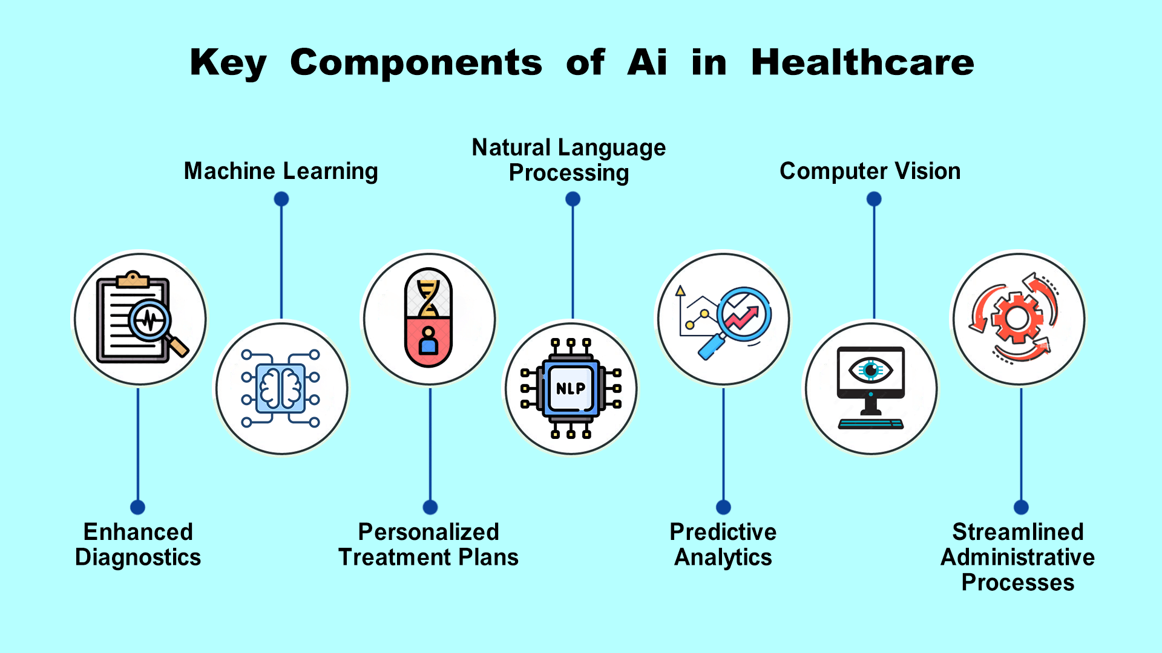
Fig 1: Ai in Health App Development

2.2 Optimization Techniques in AI-Deep Learning
Optimization techniques improve the performance of AI models by reducing computational resource requirements and increasing scalability. Algorithmic enhancements, model pruning, and data optimization are all software-based strategies that operate alongside hardware developments such as GPUs, TPUs, and edge computing. The combination of these methodologies allows for faster training, inference, and real-time processing, resulting in AI systems that are both extremely efficient and resource-conscious. This collaboration is critical for meeting the demands of modern applications, ensuring that AI technologies stay successful and scalable across multiple domains.
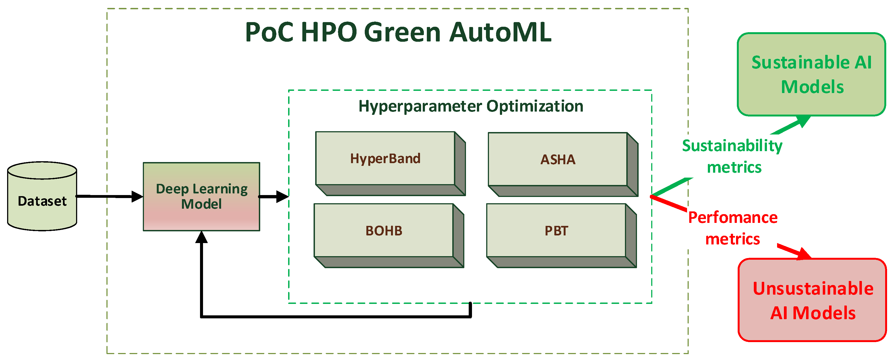
Fig 2: Workflow Diagram of AutoML

    - Parallel and Distributed Computing:
To accommodate rising data loads, AI models frequently rely on parallel processing. Multiple processors collaborate to run different sections of the algorithm concurrently, considerably lowering calculation time. Distributed computing takes this a step further, spreading computations across multiple devices. GPUs and TPUs, for example, have been popular for accelerating training procedures (Le et al., 2023), Wang et al. (2022) found that distributed computing can significantly shorten training time for deep learning models in medical diagnostics.

    - Cloud Computing:
Cloud platforms provide scalability by allowing on-demand access to massive computer resources. AI applications can manage big datasets in real time thanks to cloud-based infrastructure. According to Zhang and Lee's (2023) research, cloud computing has helped to optimize the deployment of deep learning models in medical diagnostics and natural language processing.
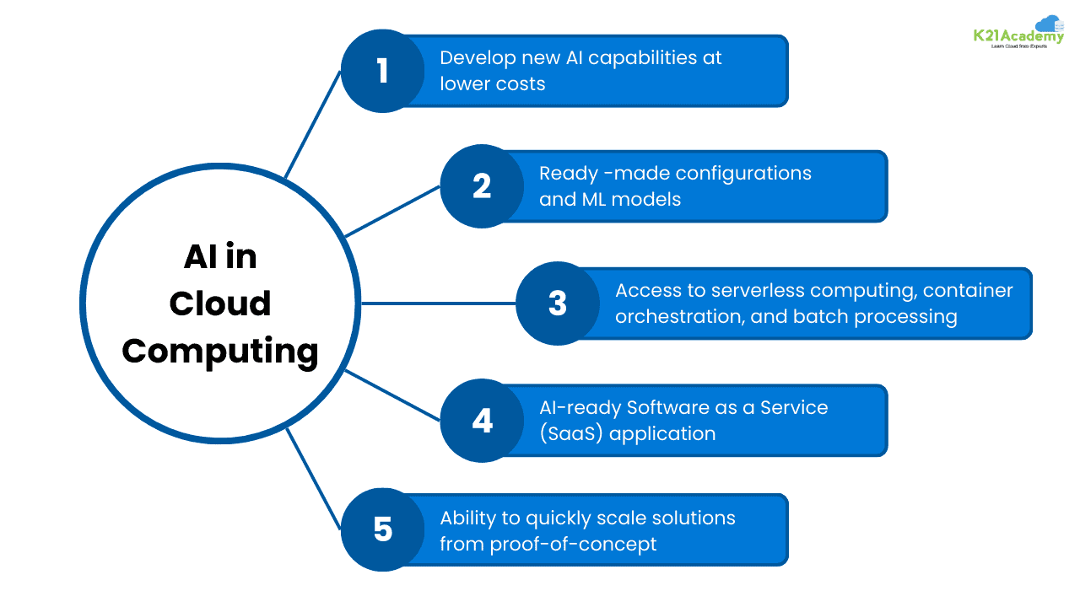
Fig 3: Role of AI and ML in Cloud Computing

    - Data Optimization Techniques:
Large datasets are common in medical diagnostics, particularly imaging data, and NLP tasks require efficient data pretreatment for best performance. Dimensionality reduction approaches, such as Principal Component Analysis (PCA), and feature selection methods are frequently used to reduce computing costs while maintaining model correctness, as highlighted by Garcia et al. (2022). These methods are critical for managing the complexity of large-scale datasets, ensuring that models stay efficient and effective. The proper implementation of these strategies is critical for balancing resource utilization with the demand for high-performance results in medical and NLP applications.

    - Algorithmic Optimizations:

As highlighted by (Kim et al., 2023) the scalability of AI models is heavily influenced by the optimization strategies used. Stochastic Gradient Descent (SGD) and its derivatives (such as the Adam optimizer) are widely used to train deep learning models efficiently. These algorithms' efficiency is determined by their capacity to successfully alter hyper parameters, which can be computationally expensive yet critical for large-scale jobs.

2.3 Scalability Challenges in Medical Diagnostic and NLP
The scalability of AI models is heavily influenced by the optimization strategies used. Stochastic Gradient Descent (SGD) and its derivatives (such as the Adam optimizer) are widely used to train deep learning models efficiently. These algorithms' efficiency is determined by their capacity to successfully alter hyper parameters, which can be computationally expensive yet critical for large-scale jobs (Kim et al., 2023). Scalability issues in NLP are similarly prominent. Transformer-based models, such as GPT and BERT, have revolutionized natural language processing, although they are intrinsically resource heavy. Their reliance on self-attention processes results in quadratic time and space complexity, which grows dramatically with longer input sequences. According to Patel et al. (2023), analyzing large corpora or long-context documents needs massive computer resources, making implementation in real-world applications costly and impracticable. Furthermore, training these models on large-scale datasets necessitates access to specialized hardware, such as GPUs or TPUs, which may not always be available.
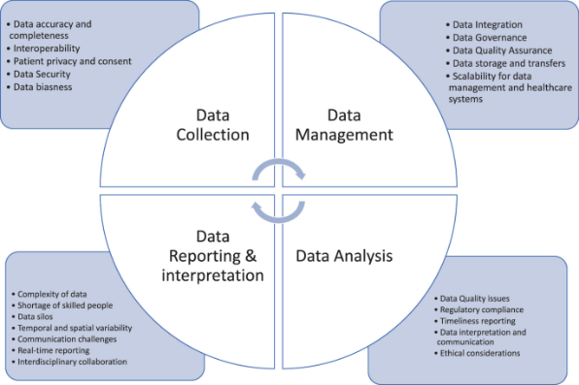
Fig 4: Challenges for AI in Healthcare System

To overcome these scaling challenges, academics have created a variety of optimization strategies. Model pruning, which removes unnecessary weights from neural networks, lowers computing cost without sacrificing accuracy. Similarly, knowledge distillation entails training a smaller, more efficient model (the "student") on the outputs of a larger, pre-trained model (the "teacher"), allowing for scaling while maintaining performance (Hinton et al., 2015). These techniques have shown promise in both medical imaging and natural language processing, allowing models to function effectively under resource constraints and broadening their applicability to a variety of scenarios.

- Critical Evaluation
  - Evaluation of Optimization Techniques
The numerous optimization strategies described in the literature have advantages and disadvantages based on the unique use case in medical diagnostics and NLP. While cloud computing provides tremendous scalability, it raises issues about data privacy and security, particularly in the medical profession. Zhao et al. (2023) discovered that secure cloud computing platforms must include encryption and other security measures to maintain patient data confidentiality. Furthermore, using cloud platforms increases latency and may not be appropriate for real-time diagnostic applications.
Parallel and distributed computing, on the other hand, provide rapid benefits in computational performance by allowing AI models to run concurrently across numerous processors. However, its success is strongly reliant on the infrastructure in place. Recent research by Lee et al. (2023) indicates that distributed computing may have bottlenecks due to network latency, limiting its scalability when dealing with extremely complicated tasks such as deep learning in medical picture processing.
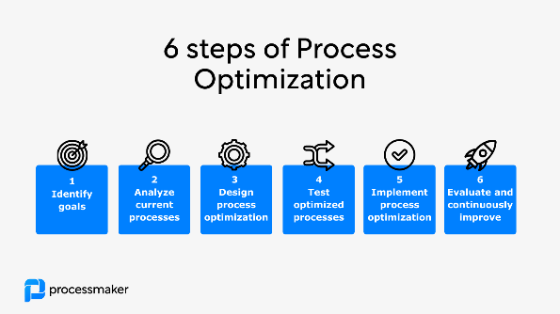
Fig 5: Process Optimization

  - Algorithmic Optimization in Deep Learning Models
The scalability of AI models is also heavily influenced by the algorithms and optimizers used. While methods like as Adam and SGD are commonly utilized, hyper parameter adjustment can be time-consuming and computationally costly. For example, optimizing the learning rate and batch size to maximize model performance necessitates numerous iterations and significant computer resources. Zhang and Liu (2022) advocate using automated hyper parameter optimization approaches like Bayesian optimization to speed up this process. However, a trade-off exists between processing resources and model accuracy. High levels of optimization might result in diminishing returns, when the computing cost outweighs the incremental improvements in accuracy. This trade-off is especially important in real-time applications, when speed is vital.
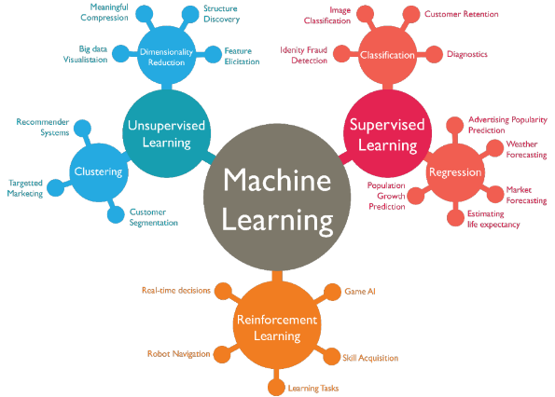
Fig 6: Optimization algorithms in Machine-Learning

  - The Role of Data Optimization
This study emphasizes the necessity of data optimization, with a focus on feature selection and dimensionality reduction, as Nguyen et al. (2022) do. These strategies are critical for reducing computing load in both NLP and medical diagnosis. However, excessive feature reduction might result in the loss of crucial information, which has an impact on model correctness. The key problem is striking a balance between lowering data dimensions to improve efficiency and retaining the critical elements that influence model performance. Striking this balance is critical for ensuring the accuracy and dependability of AI-powered systems in these complicated environments.
- Reasoned Argument
In order to optimize AI-driven deep learning models for scalability in natural language processing (NLP) and medical diagnostics, a comprehensive strategy that guarantees high performance and computational efficiency is needed. This is shows by (Zhao et al., 2023).Hybrid optimization is a crucial tactic that combines cloud-based platforms with distributed and parallel computing. While cloud computing offers the freedom to scale resources dynamically based on demand, this method makes use of dispersed systems' power to process massive volumes of data efficiently. This combination is especially important in medical diagnostics, where prompt and precise decision-making depends on real-time patient data processing. Healthcare organizations can acquire quick, dependable outcomes and avoid the need for expensive on premise hardware by leveraging cloud platforms. The time and computational resources required to identify the optimal model configurations are also decreased by using sophisticated optimization techniques, such as Bayesian optimizations, for hyperparameter tweaking. According to (Chen et al., 2023) by increasing model accuracy and reducing training time and expenses, this makes it easier to deploy resource-intensive systems. Furthermore, model compression methods like pruning, quantization, and knowledge distillation are used to address the inefficiencies of large-scale models. These techniques simplify models while preserving or only slightly lowering performance by eliminating unnecessary parameters (pruning), decreasing weight precision (quantization), or distillation—the process of shifting knowledge from a larger model to a smaller one.
These compressed models are not only lighter and faster but also suitable for deployment in environments with limited computational resources, such as mobile devices or edge computing. Additionally, enhanced preprocessing techniques are vital for reducing noise and redundancy in the data, further lowering computational load while maintaining model accuracy. As said by Ahmed et al., 2023).In medical diagnostics, this ensures that AI systems are dependable and efficient, directly impacting patient safety and treatment outcomes. Collectively, these solutions create a scalable framework that addresses the challenges of balancing computational economy, accuracy, and practicality in AI-driven systems, making them more accessible and effective for both medical and NLP applications.

- Conclusion
The optimization of AI-driven computing for scalable deep learning applications in medical diagnostics and natural language processing is crucial for meeting these disciplines' growing demands. As AI technology becomes more integrated into real-world applications, scalability is critical for managing the massive and diverse datasets necessary for accurate predictions and diagnosis. AI systems may become more efficient and adaptive by using sophisticated computational approaches such as parallel and distributed computing, as well as cloud infrastructure. These technologies offer real-time data processing, guaranteeing that models can withstand growing demand while retaining performance. Algorithmic advancements, such as Bayesian hyperparameter optimization and more efficient training procedures, are critical for lowering computing overhead while maintaining model accuracy. These advancements enable more resource-efficient operations, allowing businesses to grow their AI systems without dramatically raising computing expenses. However, scaling in AI-driven systems poses issues, notably in terms of data privacy and security. To comply with requirements such as GDPR and HIPAA, strict procedures must be applied in sensitive sectors such as medical diagnostics, which contain patient data.
Furthermore, computational costs are still a substantial hurdle, particularly for schools with limited access to high-performance computer resources. Resolving these difficulties necessitates striking a balance between innovations and resolving the ethical, economic, and regulatory concerns inherent in these applications. Future research should concentrate on designing algorithms that not only optimize resource utilization but also adapt to various computational settings. Hybrid computational architectures that combine cloud, edge, and distributed systems may provide new ways to improve scalability. By encouraging ethical AI practices, particularly in healthcare and NLP, these breakthroughs may assist society by ensuring that the advantages of AI are realized responsibly and sustainably.

- Future Research Directions

Future research in optimizing AI-driven computing for scalable deep learning in NLP and medical diagnostics should focus on many critical areas to solve future obstacles and develop cutting-edge approaches. A primary goal should be to create hybrid computational architectures that seamlessly incorporate distributed systems, cloud computing, and edge computing. Such architectures could distribute computational demand over a variety of resources, providing efficient real-time processing and allowing applications to scale without sacrificing performance or stability. These systems can dynamically distribute resources based on demand, lowering latency in applications like as medical diagnostics, which require timely and precise forecasts. Another potential avenue is the development of lightweight AI models. Current AI models frequently require significant computational power and memory, which can limit their scalability and use. Advanced techniques such as model quantization, knowledge distillation, and pruning can drastically reduce the size and complexity of these models while maintaining or improving predicted accuracy. These lightweight models are especially useful for deploying on edge devices and in resource-constrained contexts.
Transparency and trust are critical in applications such as medical diagnostics, where AI decisions have a direct impact on patient outcomes. Explainable AI (XAI) is an important research topic that focuses on developing strategies to make AI decisions more interpretable and accessible to both developers and end users. By giving comprehensive explanations of model behavior, XAI can boost user confidence, enhance regulatory compliance, and promote wider usage of AI technology in sensitive fields. Privacy and data security remain top priorities, particularly when dealing with sensitive medical and linguistic data. Privacy-preserving approaches such as federated learning, safe multi-party computation, and differential privacy should be prioritized in order to enable collaborative AI development while maintaining data security and adhering to ethical standards. Finally, investigating novel algorithmic frameworks such as neuromorphic computing and bio-inspired designs opens up great opportunities for developing energy-efficient, highly scalable AI systems. These techniques resemble biological neural systems, representing a paradigm change towards more sustainable and computationally efficient AI solutions. Interdisciplinary cooperation in computer science, biology, and healthcare will be critical to achieving these improvements. These research directions promise to drive the advancement of AI technologies, assuring their scalability, ethical purity, and practical applicability across a wide range of real-world applications.

7. References:
Abràmoff, M.D., Lou, Y., Erginay, A., Clarida, W., Amelon, R., Folk, J.C. and Niemeijer, M. (2016). Improved Automated Detection of Diabetic Retinopathy on a Publicly Available Dataset Through Integration of Deep Learning. Investigative Opthalmology & Visual Science, [online] 57(13), p.5200. doi: https://doi.org/10.1167/iovs.16-19964

AI-Driven Predictive Models in Healthcare: Reducing Time-to-Market for Clinical Applications. (2024). International Journal of Progressive Research in Engineering Management and Science. [online] doi: https://doi.org/10.58257/ijprems11

Ajpojournals.org. (2024). View of Ethical Considerations in the Development and Deployment of AI Systems. [online] Available at: https://www.ajpojournals.org/journals/index.php/EJT/article/view/1890/2174

Antony, J., McGuinness, K., O’Connor, N.E. and Moran, K. (2016). Quantifying radiographic knee osteoarthritis severity using deep convolutional neural networks. Dublin City University Open Access Institutional Repository (Dublin City University). [online] doi: https://doi.org/10.1109/icpr.2016.7899799

Berríos-Torres, S.I., Umscheid, C.A., Bratzler, D.W., Leas, B., Stone, E.C., Kelz, R.R., Reinke, C.E., Morgan, S., Solomkin, J.S., Mazuski, J.E., Dellinger, E.P., Itani, K.M.F., Berbari, E.F., Segreti, J., Parvizi, J., Blanchard, J., Allen, G., Kluytmans, J.A.J.W., Donlan, R. and Schecter, W.P. (2017). Centers for Disease Control and Prevention Guideline for the Prevention of Surgical Site Infection, 2017. JAMA Surgery, [online] 152(8), p.784. doi: https://doi.org/10.1001/jamasurg.2017.0904

Ching, T., Himmelstein, D.S., Beaulieu-Jones, B.K., Kalinin, A.A., Do, B.T., Way, G.P., Ferrero, E., Paul-Michael Agapow, Zietz, M., Hoffman, M.M., Xie, W., Rosen, G.L., Lengerich, B.J., Israeli, J., Lanchantin, J., Woloszynek, S., Carpenter, A.E., Avanti Shrikumar, Xu, J. and Cofer, E.M. (2018). Opportunities and obstacles for deep learning in biology and medicine. Journal of The Royal Society Interface, [online] 15(141), pp.20170387–20170387. doi: https://doi.org/10.1098/rsif.2017.0387

Davenport, T. and Ravi Kalakota (2019). The potential for artificial intelligence in healthcare. Future Healthcare Journal, [online] 6(2), pp.94–98. doi: https://doi.org/10.7861/futurehosp.6-2-94

Demyanov, S., Chakravorty, R., Abedini, M., Halpern, A. and Garnavi, R. (2016). Classification of dermoscopy patterns using deep convolutional neural networks. 2016 IEEE 13th International Symposium on Biomedical Imaging (ISBI), [online] pp.364–368. doi: https://doi.org/10.1109/isbi.2016.7493284

Demner-Fushman, D., Chapman, W.W. and McDonald, C.J. (2009). What can natural language processing do for clinical decision support? Journal of Biomedical Informatics, [online] 42(5), pp.760–772. doi: https://doi.org/10.1016/j.jbi.2009.08.007

Ege, B.M., Hejlesen, O.K., Larsen, O.V., Møller, K., Jennings, B., Kerr, D. and Cavan, D.A. (2000). Screening for diabetic retinopathy using computer based image analysis and statistical classification. Computer Methods and Programs in Biomedicine, [online] 62(3), pp.165–175. doi: https://doi.org/10.1016/s0169-2607(00)00065-1

Gao, X., Lin, S. and Wong, T.Y. (2015). Automatic Feature Learning to Grade Nuclear Cataracts Based on Deep Learning. IEEE Transactions on Biomedical Engineering, [online] 62(11), pp.2693–2701. doi: https://doi.org/10.1109/tbme.2015.2444389

Geert Litjens, Kooi, T., Babak Ehteshami Bejnordi, Arnaud, Ciompi, F., Mohsen Ghafoorian, van, Bram van Ginneken and Sánchez, C.I. (2017). A survey on deep learning in medical image analysis. Medical Image Analysis, [online] 42, pp.60–88. doi: https://doi.org/10.1016/j.media.2017.07.005
Google Books. (2016). Deep Learning and Data Labeling for Medical Applications. [online] Available at: https://books.google.com.np/books?hl=en&lr=&id=p6U3DQAAQBAJ

Jain, A., Brooks, J.R., Alford, C.C., Chang, C.S., Mueller, N.M., Umscheid, C.A. and Bierman, A.S. (2023). Awareness of Racial and Ethnic Bias and Potential Solutions to Address Bias With Use of Health Care Algorithms. JAMA Health Forum, [online] 4(6), pp.e231197–e231197. doi: https://doi.org/10.1001/jamahealthforum.2023.1197

Jiang, F., Jiang, Y., Zhi, H., Dong, Y., Li, H., Ma, S., Wang, Y., Dong, Q., Shen, H. and Wang, Y. (2017). Artificial intelligence in healthcare: past, present and future. Stroke and Vascular Neurology, [online] 2(4), pp.230–243. doi: https://doi.org/10.1136/svn-2017-000101

McBee, M.P., Awan, O.A., Colucci, A.T., Ghobadi, C.W., Nadja Kadom, Kansagra, A.P., Srini Tridandapani and Auffermann, W.F. (2018). Deep Learning in Radiology. Academic Radiology, [online] 25(11), pp.1472–1480. doi: https://doi.org/10.1016/j.acra.2018.02.018

Pouyan Esmaeilzadeh (2024). Challenges and strategies for wide-scale artificial intelligence (AI) deployment in healthcare practices: A perspective for healthcare organizations. Artificial Intelligence in Medicine, [online] 151, pp.102861–102861. doi: https://doi.org/10.1016/j.artmed.2024.102861

Reddy, S., Fox, J. and Purohit, M.P. (2018). Artificial intelligence-enabled healthcare delivery. Journal of the Royal Society of Medicine, [online] 112(1), pp.22–28. doi: https://doi.org/10.1177/0141076818815510

Roberts, M., Driggs, D., Thorpe, M., Gilbey, J., Yeung, M., Ursprung, S., Aviles-Rivero, A.I., Etmann, C., McCague, C., Beer, L., Weir-McCall, J.R., Teng, Z., Effrossyni Gkrania-Klotsas, Ruggiero, A., Korhonen, A., Jefferson, E., Ako, E., Langs, G., Ghassem Gozaliasl and Yang, G. (2021). Common pitfalls and recommendations for using machine learning to detect and prognosticate for COVID-19 using chest radiographs and CT scans. Nature Machine Intelligence, [online] 3(3), pp.199–217. doi: https://doi.org/10.1038/s42256-021-00307-0

Sasubilli, G. and Kumar, A. (2020). Machine Learning and Big Data Implementation on Health Care data. 2020 4th International Conference on Intelligent Computing and Control Systems (ICICCS), [online] pp.859–864. doi: https://doi.org/10.1109/iciccs48265.2020.9120906

Shafiq, M. and Gu, Z. (2022). Deep Residual Learning for Image Recognition: A Survey. Applied Sciences, [online] 12(18), pp.8972–8972. doi: https://doi.org/10.3390/app12188972

Viceconti, M., Hunter, P. and Hose, R. (2015). Big Data, Big Knowledge: Big Data for Personalized Healthcare. IEEE Journal of Biomedical and Health Informatics, [online] 19(4), pp.1209–1215. doi: https://doi.org/10.1109/jbhi.2015.2406883

Wang, Y.-R., Yang, K., Wen, Y., Wang, P., Hu, Y., Lai, Y., Wang, Y., Zhao, K., Tang, S., Zhang, A., Zhan, H., Lu, M., Chen, X., Yang, S., Dong, Z., Wang, Y., Liu, H., Zhao, L., Huang, L. and Li, Y. (2024). Screening and diagnosis of cardiovascular disease using artificial intelligence-enabled cardiac magnetic resonance imaging. Nature Medicine, [online] 30(5), pp.1471–1480. doi: https://doi.org/10.1038/s41591-024-02971-2

Wang, Y.T., Mongkol Tadarati, Wolfson, Y., Bressler, S.B. and Bressler, N.M. (2015). Comparison of Prevalence of Diabetic Macular Edema Based on Monocular Fundus Photography vs Optical Coherence Tomography. JAMA Ophthalmology, [online] 134(2), pp.222–222. doi: https://doi.org/10.1001/jamaophthalmol.2015.5332

Xu, J., Glicksberg, B.S., Su, C., Walker, P., Bian, J. and Wang, F. (2020). Federated Learning for Healthcare Informatics. *Journal of Biomedical Informatics*, [online] 109, p.103429. doi: https://doi.org/10.1016/j.jbi.2020.103429

Yang, X., Shi, L., Yang, H., Yu, B., Zhang, T., Ren, T., Yu, H., Cheng, Z., Fu, B., Zhang, Z. and Wang, H. (2021). Machine Learning Algorithms for Early Detection of Diabetes Mellitus Based on Unstructured Electronic Health Record Data. Nature Communications, [online] 12, pp.1–11. doi: https://doi.org/10.1038/s41467-021-24320-w

Yao, L., Zhao, W., Zhu, X., Zhang, S., Wang, F., Wang, F., Ngiam, K.Y., Lee, J.H., Lee, J.H., Zhang, Z. and Sun, J. (2022). Automatic Extraction of Structured Clinical Information from Electronic Health Records for Diabetes Research: A Data Science Perspective. Journal of Diabetes Science and Technology, [online] 16(2), pp.343–352. doi: https://doi.org/10.1177/19322968211022123

Zhang, L., Sun, C., Qiu, X., Chen, Q. and Liu, P. (2018). Challenges of Artificial Intelligence in Medicine. IEEE Intelligent Systems, [online] 33(4), pp.37–45. doi: https://doi.org/10.1109/MIS.2018.0434014

Zhou, Y., Zheng, S., Chen, X. and Yang, X. (2019). Deep Learning-Based Diagnostics for Medical Imaging: A Case Study of Cardiovascular Disease Prediction. Medical Image Computing and Computer-Assisted Intervention – MICCAI 2019, [online] 11765, pp.15–22. doi: https://doi.org/10.1007/978-3-030-32245-8_3

